66.08.22
To Redmond Barry
MS 12161 Melbourne Intercolonial Exhibition 1866-7, box 2781/2 a-b, papers of Sir Redmond Barry, La Trobe Australian Manuscripts Collection, State Library of Victoria, Melbourne.

22/8/66
The Commissioners, dear Sir Redmond, so utterly disapproved of the idea of identifying the Exhibition with the issue of the physiographical Atlas, that I could not for a moment think to claim of you in your presidential position to follow the subject up. Indeed I was instructed to convey to his Excellency the intimation, that the work was beyond the scope and not within the time of our duties nor within our means and I was told that any suggestions concerning the work I could not offer as a Commissioner but as a private man. It is pleasing to me that you have not abandoned the idea also, and that you will write to Colonel Browne Before I received (this noon) your friendly note I had posted a letter to the Tasmanian Governor with a copy of the Report written by me & adopted by Dr Bleasdale & Prof McCoy. I suggested also, that his Excellency might apply to his Viceregal Colleagues and obtain a subsidy from each colony, when the Atlas could be published in Melbourne.
I must beg however to mention distinctly, that though you very thoughtfully alluded to Johnsons physical Atlas in your request for information all the notes would have served only for essays and perhaps for one or two maps not for an Atlas. Indeed I all along only understood that essays were to be written & and for such, as far as plants are concerned, I only took the responsibility when called on by the Commission. Essays may be written at comparatively trifling labour and small expense. How different with an Atlas! It may absorbe six months of my spare time to reduce all the extant information to a map. Essays can without injury be incomplete, not so maps. Allow me to speak in this frank manner on the subject, because it will require large means and much time to accomplish what I reported on. I will however be happy to render my humble aid in any way I can, but I see not how the work can be connected with the Exhibition itself. It ought to be an independent measure, supported in the same manner as for 10 years the Governments of N. S Wales, Queensland, South Australia & Victoria pledged themselfes to support the work of Bentham & myself. The responsibility of the editorship should devolve on one gentleman for each map or at least each science. Were a number of data sent to me indiscriminately in my branch I should decline to accept them. I can see my way clear to communicate directly with the few Australian observers, whose notes would be of any value whatever. Any other means of working would become embarrassing & discouraging. I should prefer a special copperplate for each of the 10 or 12 maps. Each editor of the map could lay it aside for annual additions & be thus independent of his fellow laborers. At the whole I believe your own ideas are expressed in my report, but I shall be happy to have a full evening consultation with you on the subject, and it will add to the many well deserved laurels which you reaped, if your influence brings this work to a glorious conclusion.
I have an idea to exemplify the huge dimensions of Eucalyptus Stuartiana and Eucalyptus goniocalyx (both described and discovered by me) by getting slaps from the base, middle parts of stem, uppermost part of stem, middle branches & top branches to construct them into a monumental structure. I have asked two people at Dandenong, to give me the necessary information as to cost, and possibly I shall bring the project before the Commission, though in candor I must confess, that notwithstanding all my most economical arrangements some of the Commissioners seem to think that I am careless in expenditure. Hence I feel little courage to suggest anything or undertake anything. You will however kindly see what structure I propose, by the rough sketch I now at a late night hour hurriedly delineate.
The slaps would [be] cemented together with some adhesive substance and the fissures painted in imitation of the bark. The structure would be hollow, & could have windows & be utilized inside. The tablets would give the hight of the stem at which the sections were taken. The ficture would be internal hardwood beams. Rustic ornamentations might be applied. The roads are now too bad to draw the slaps, but the structure might yet be built in November or December and serve as an additional attraction at that time. A special vote will be required for it, as the wood & Gyps fruit specimens will absorbe the £250 at my disposal for both Exhibitions together. The structure might be made so durable as to find a place permanently in a cemetery or park. Both Eucalyptus goniocalyx & E. Stuartiana attain a hight of 400'.
In reference to the horticultural Exhibition, the Society of which I am Vicepresident, can only as a Society give aid by keeping faith with its subscribers, who must enjoy the privilege of access on showdays & must be awarded with certificates. Our rules require us also to carry out ourselfes the administration of shows & if we exhibit at the Exhibition we can not have our vernal festival and autumnal show. But if the dignity of the Society is acknowledged, if the elaboration of the prize schedules, the adjudication & other detail arrangements are left to the Society's Committee there is nothing in our rules to prevent us from holding the shows in the Exhibition Court instead [of] at the botanic Garden. But if the shows or at least our three shows cannot be under the special auspices and management of our Society we could only as individual members assist in the show. The Committee of the Society is however very eager to assist the Commission officially as indicated, or if this cannot be done after the varied invitations then we can each privately contribute to the show, and as Director of the bot. garden I will do all I can.
Ever with most friendly regards, dear Sir Redmond, your
Ferd. Mueller

It was very kind to absolve my gardener so speedily from attendance.
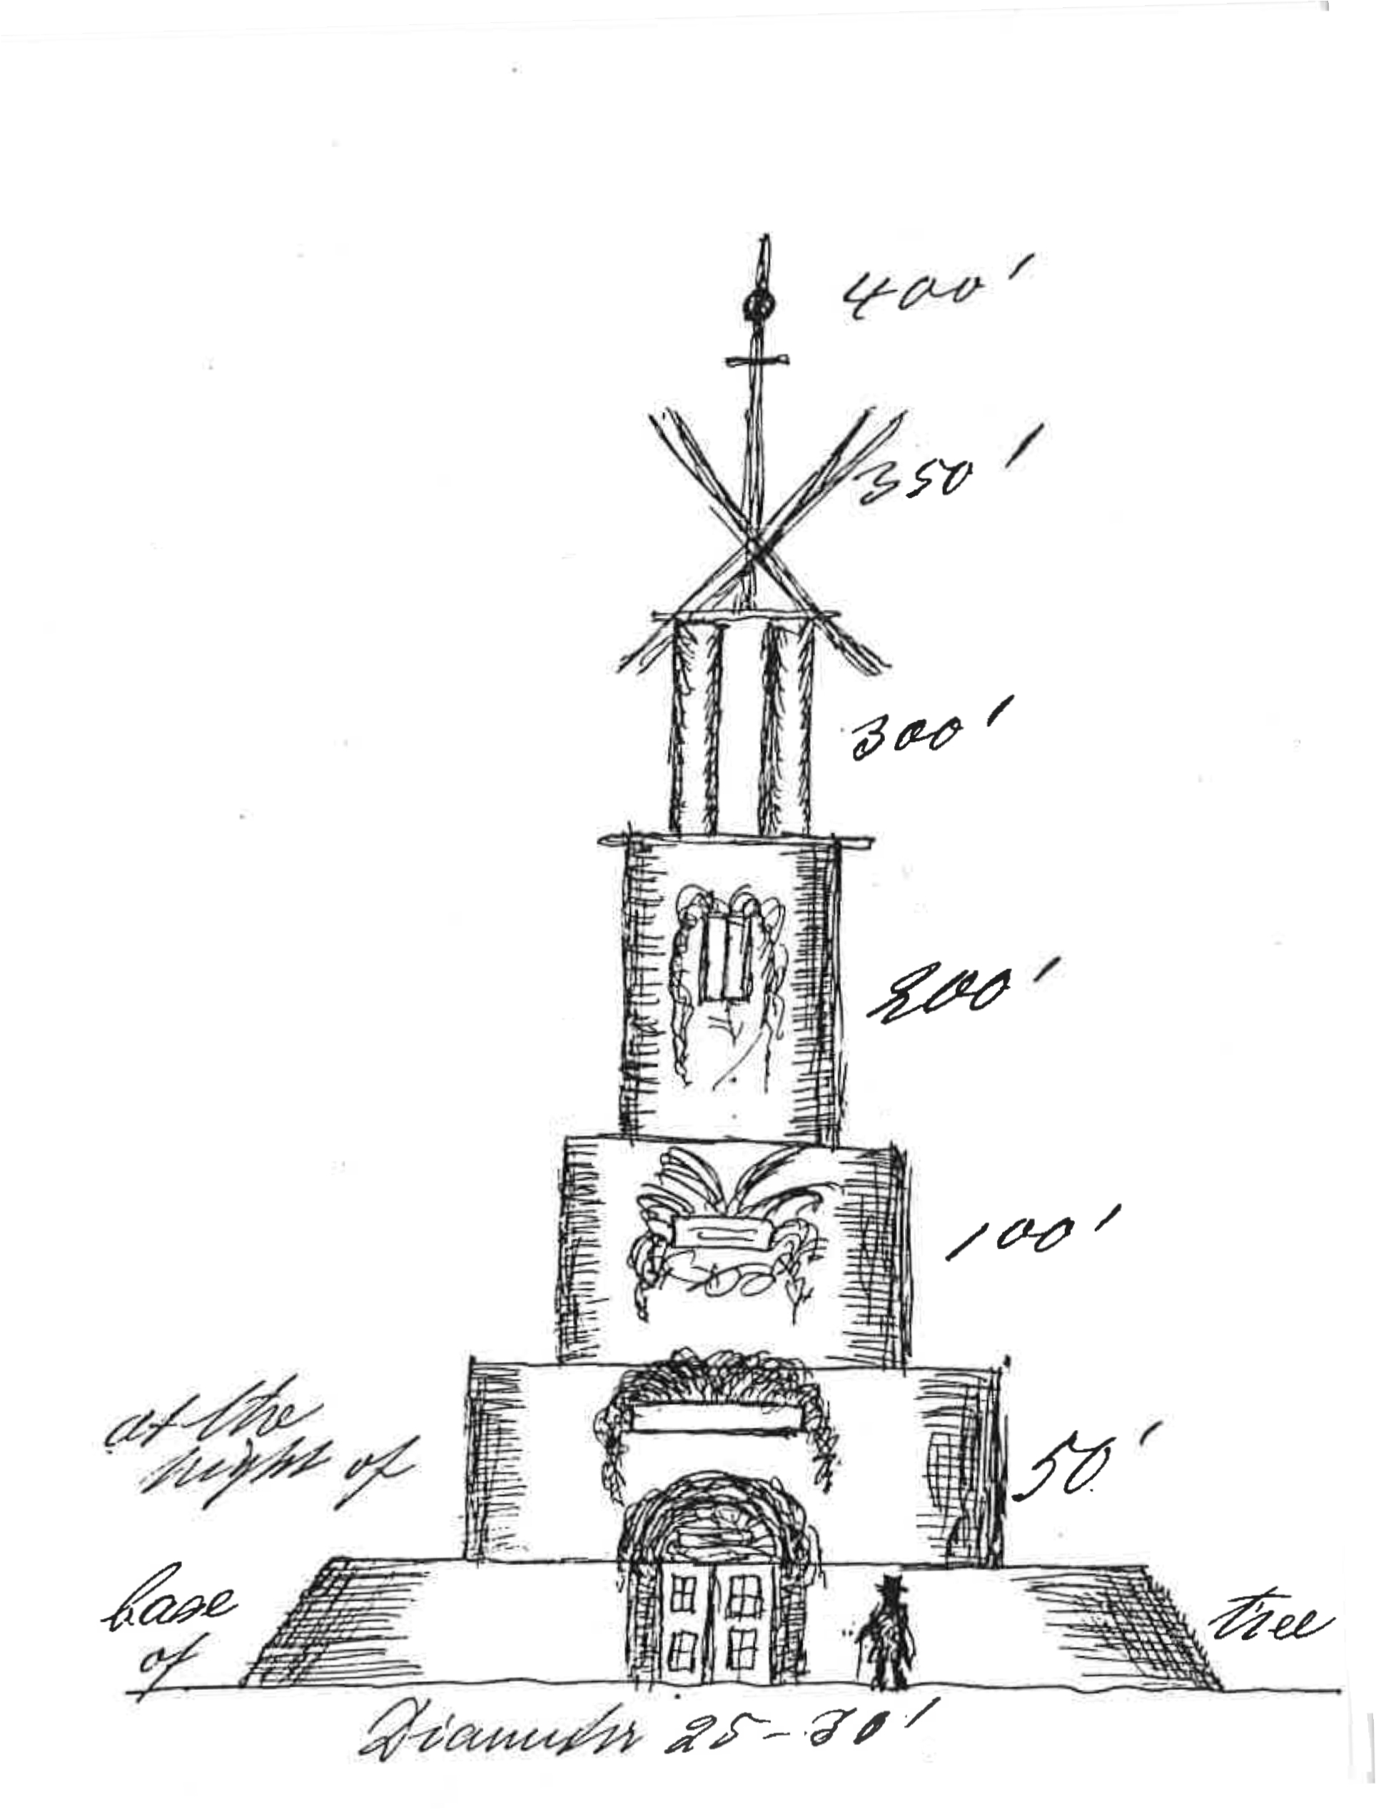

Intercolonial Exhibition of Australasia, Melbourne, 1866-7.
See also M to J. Hooker, 28 July 1866 and M et al. to the Commission for the Intercolonial Exhibition, August 1866 (in this edition as 66-08-00a).
Letter not found.
See M to T. Gore Browne, August 1866 (in this edition as 66-08-00e).
A. Johnston (1850) or a later edition; see discussion in M et al. to the Commission for the Intercolonial Exhibition, August 1866 (in this edition as 66-08-00a), n. 4.
Bentham (1863-78).
66-08-22_image01.jpg Drawing on a separate, smaller sheet enclosed with the letter.
editorial addition.
gypsum.
Intercolonial Exhibition of Australasia, Melbourne, 1866-7 and Exposition Universelle, Paris, 1867.
i.e. summer.
editorial addition.
MS marginal addition by M: 'These are the views I expressed at the Horticultl Soc Committee meeting when the Deputation was appointed'.

